Yektanet Business Data Analyst Candidate

Roozbeh Dadashzadeh

[roozbeh.dadashzadeh@gmail.com](mailto:roozbeh.dadashzadeh@gmail.com)

+989919002212

# Task #1

## Part 1

|  |  |  |  |  |  |
| --- | --- | --- | --- | --- | --- |
| تعرفه خدمات دیوار | خدمات | استخدام و کاریابی | وسایل نقلیه | املاک | سایر دسته بندی ها |
| ثبت آگهی | 10000 | 15000 | 0 | 0 | 0 |
| نردبان | 10000 | 15000 | 10000 | 10000 | 5000 |
| فوری | 6000 | 6000 | 6000 | 6000 | 6000 |
| فوری و نردبان | 10000 | 15000 | 10000 | 10000 | 6000 |
| تمدید | 1000 | 1000 | 1000 | 1000 | 1000 |
| تمدید و نردبان | 10000 | 15000 | 10000 | 10000 | 5000 |
| لینک وبسایت | 20000 | 0 | 0 | 0 | 0 |
| ارسال بیش از حد مجاز | 0 | 0 | 10000 | 10000 | 5000 |

|  |  |  |  |  |  |  |  |  |  |
| --- | --- | --- | --- | --- | --- | --- | --- | --- | --- |
| دسته‌بندی آگهی | سهم از کل آگهی‌ها | سهم از کل آگهی‌های نردبان‌شده | تعداد آگهی در هر 100 آگهی | تعداد آگهی نردبان شده از هر 100 آگهی | حداقل درآمد دیوار* | سهم از در آمد | اگر تعداد آگهی های نردبان شده یا تعرفه ها یک درصد افزایش پیدا کند. | سهم از افزایش درآمد | حداقل درآمد جدید * |
| وسایل نقلیه | 39.00% | 30.00% | 39 | 11.7 | 117000 | 53.44% | 1170 | 78.56% | 118170 |
| املاک | 6.00% | 25.00% | 6 | 1.5 | 15000 | 6.85% | 150 | 10.07% | 15150 |
| لوازم الکترونیکی | 12.00% | 3.00% | 12 | 0.36 | 1800 | 0.82% | 18 | 1.21% | 1818 |
| خدمات | 2.50% | 2.50% | 2.5 | 0.0625 | 25625 | 11.70% | 6.25 | 0.42% | 25631.25 |
| سرگرمی و فراغت | 6.00% | 17.00% | 6 | 1.02 | 5100 | 2.33% | 51 | 3.42% | 5151 |
| استخدام و کاریابی | 3.00% | 12.50% | 3 | 0.375 | 50625 | 23.12% | 56.25 | 3.78% | 50681.25 |
| مربوط به خانه | 4.00% | 5.00% | 4 | 0.2 | 1000 | 0.46% | 10 | 0.67% | 1010 |
| وسایل شخصی | 18.00% | 2.00% | 18 | 0.36 | 1800 | 0.82% | 18 | 1.21% | 1818 |
| اجتماعی | 2.00% | 0.50% | 2 | 0.01 | 50 | 0.02% | 0.5 | 0.03% | 50.5 |
| برای کسب و کار | 7.50% | 2.50% | 7.5 | 0.1875 | 937.5 | 0.43% | 9.375 | 0.63% | 946.875 |
| Total | 100.00% | 100.00% | 100 | 15.775 | 218937.5 | 100.00% | 1489.375 | 100.00% | 220426.9 |
|  |  |  |  |  |  |  |  |  | 0.68% |

For this analysis, I considered just 100 advertises with the distribution expressed in the table, and each advertises only have been submitted and laddered just once.

With the assumption of improving the number of advertises by one percent and with normal distribution, the calculations have been made and the results are as follow:

* With a 1 percent improvement, the sales go up by 0.68 percent which results in 68% efficiency in this criteria. It is worth mentioning that with the marketing expenses data available, it can be possible to calculate the efficiency more accurately.
* Vehicle and Hiring ads contribute to almost 75% of Divar’s revenue.
* In the case of 1% improvement, Vehicle ads make 80 percent of the added revenue and Real Estate ads come in second place with a 10% contribution.

## Part 2

Incentives include offering batch discounts on ads in the most profitable categories like Vehicles and Real Estated but the fact that Divar should be synchronized and optimized with mentioned markets macroeconomics figures like inflation and recession is worth considering in the analysis.

As the sole purpose of Divar is to improve sales, Divar has 2 pathways. One is increasing the prices and the other is increasing ads by integrating marketing strategies. Divar, as a market leader, should be careful to not lose its market share because with a market challenger like Sheypoor it would be hard to gain back the advantage. So I suggest that price increase should be off the table and they set their strategies to promote laddering benefits and encourage current users with discounts or campaign offerings.

## Part 3

Strategies impacts are as follow:

* It increases the laddered ads as people tend to use the opportunities where they get more numbers of offerings with lesser price than before.
* The laddered ads conversion rate may not increase as the number of laddered ads would because of a probable increase in non-laddered ads.
* Divar’s revenue would increase by almost 70 percent in the worst-case scenario where the increased ads are distributed uniformly among different ad categories.

## Part 4

As Sheypoor is the market challenger and needs to improve its market share, it should look for opportunities that reside in Divar’s weaknesses. It means that Sheypoor should invest in categories in which Divar performs poorly like services while trying to attract Divar’s high-performance category users by offering lower prices.

# Task #2

## Part 1

Managers Dashboard

*Interactive dashboard is available within the task files as **Managers Dashboard.twb**.

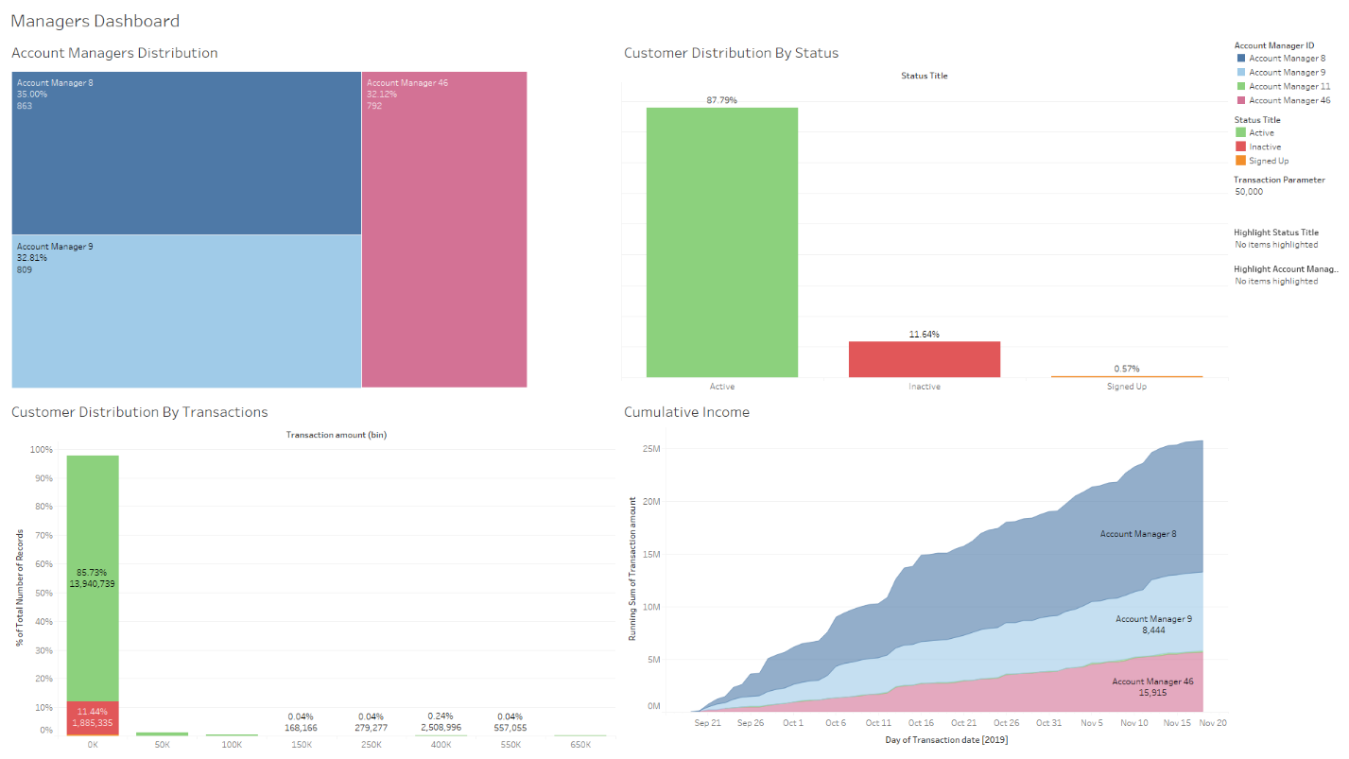

Account Managers Dashboard

*Interactive dashboard is available within the task files as **Account Managers Dashboard.twb**.

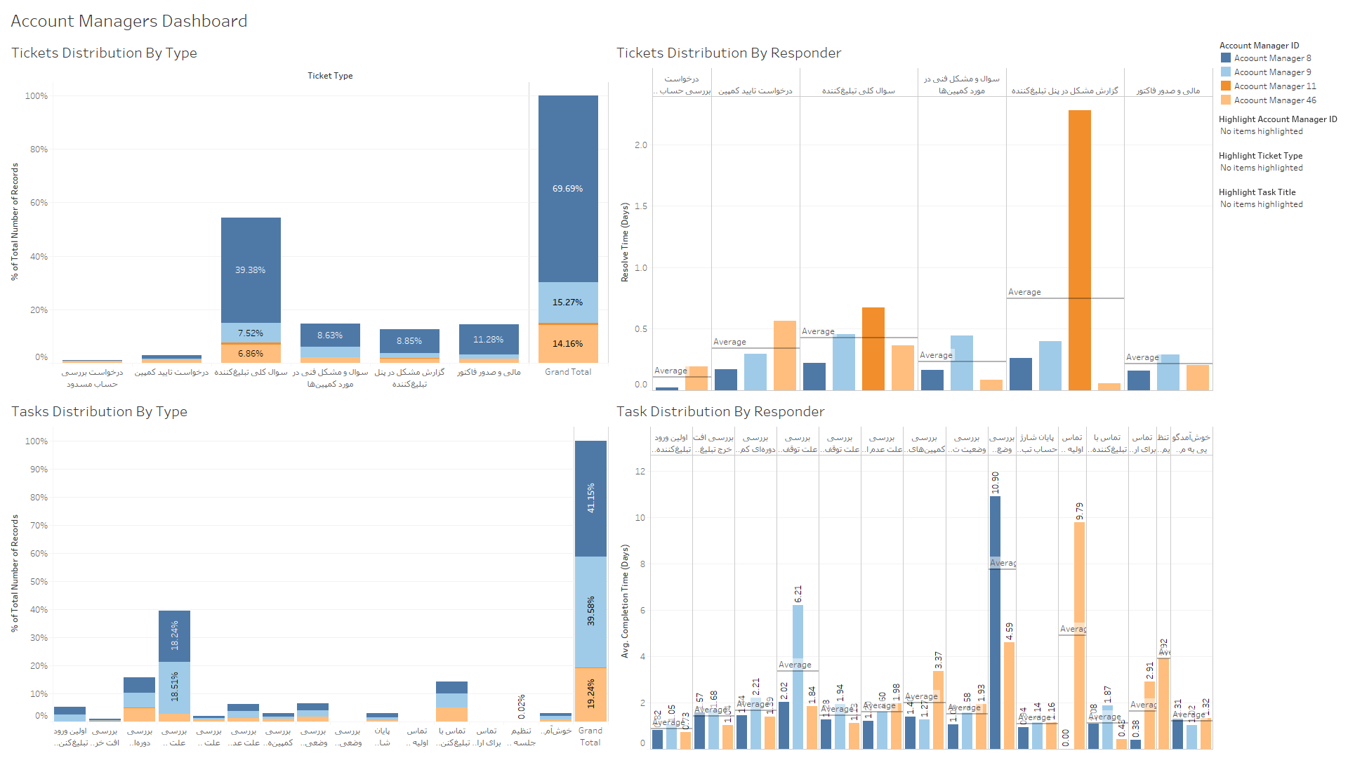

## Part 2

Customer Segmentation

As Yektanet wishes to maximize the rate of retention while maximizing the number of account deposits, I think one possible way to segment the customer is by their total amount of transactions made while considering whether they are active or not.

Active customers who have made an acceptable amount of transaction (as the picture below suggests above 250000) are more likely to continue using Yektanet’s services (retention rate and gross profit improve). On the other hand, Inactive users with high amounts of the transaction are probably the best 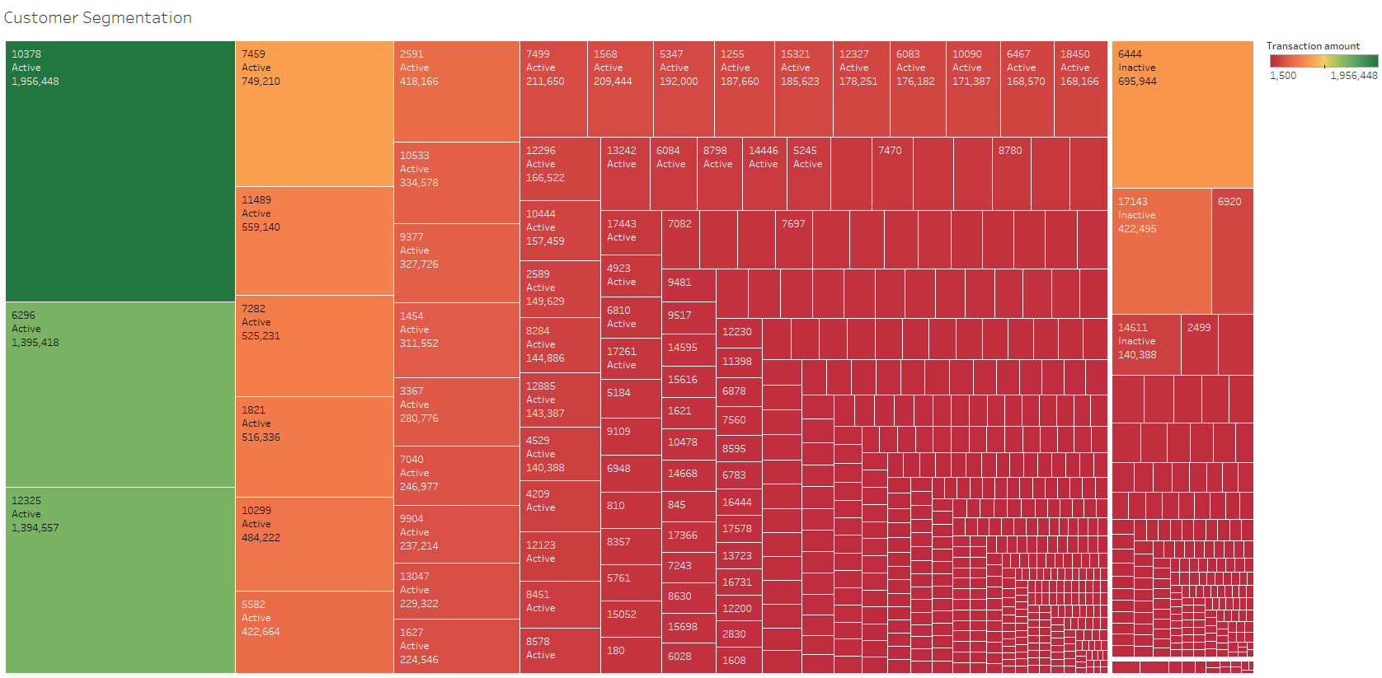candidates to switch back to Yektanet (total sale improves).

## Part 3

Account Managers Performance Dashboard

*Interactive dashboard is available within the task files as **Account Managers Performance Dashboard.twb**.

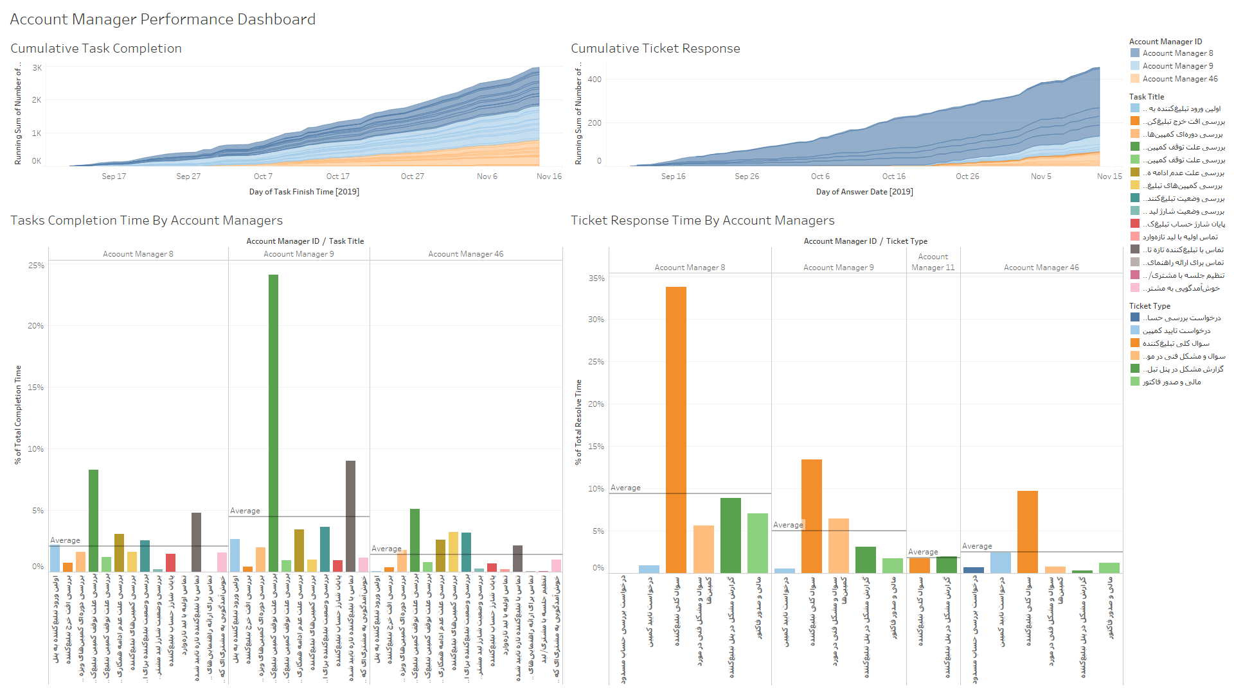

To assess the performance of account managers we must compare their performance with other managers and simultaneously with themselves. We should compare their average time spent on responding to tickets and time spent to complete the task.

With the help of the Dashboard, we can examine their relative performance on each specific category of tasks or tickets compared to other managers.

In another segment of the dashboard, their running total number of customers served has been shown. We can now monitor totally which managers are doing better in terms of tickets respond or tasks completed.

## Part 4

Efficient, Inefficient Tasks

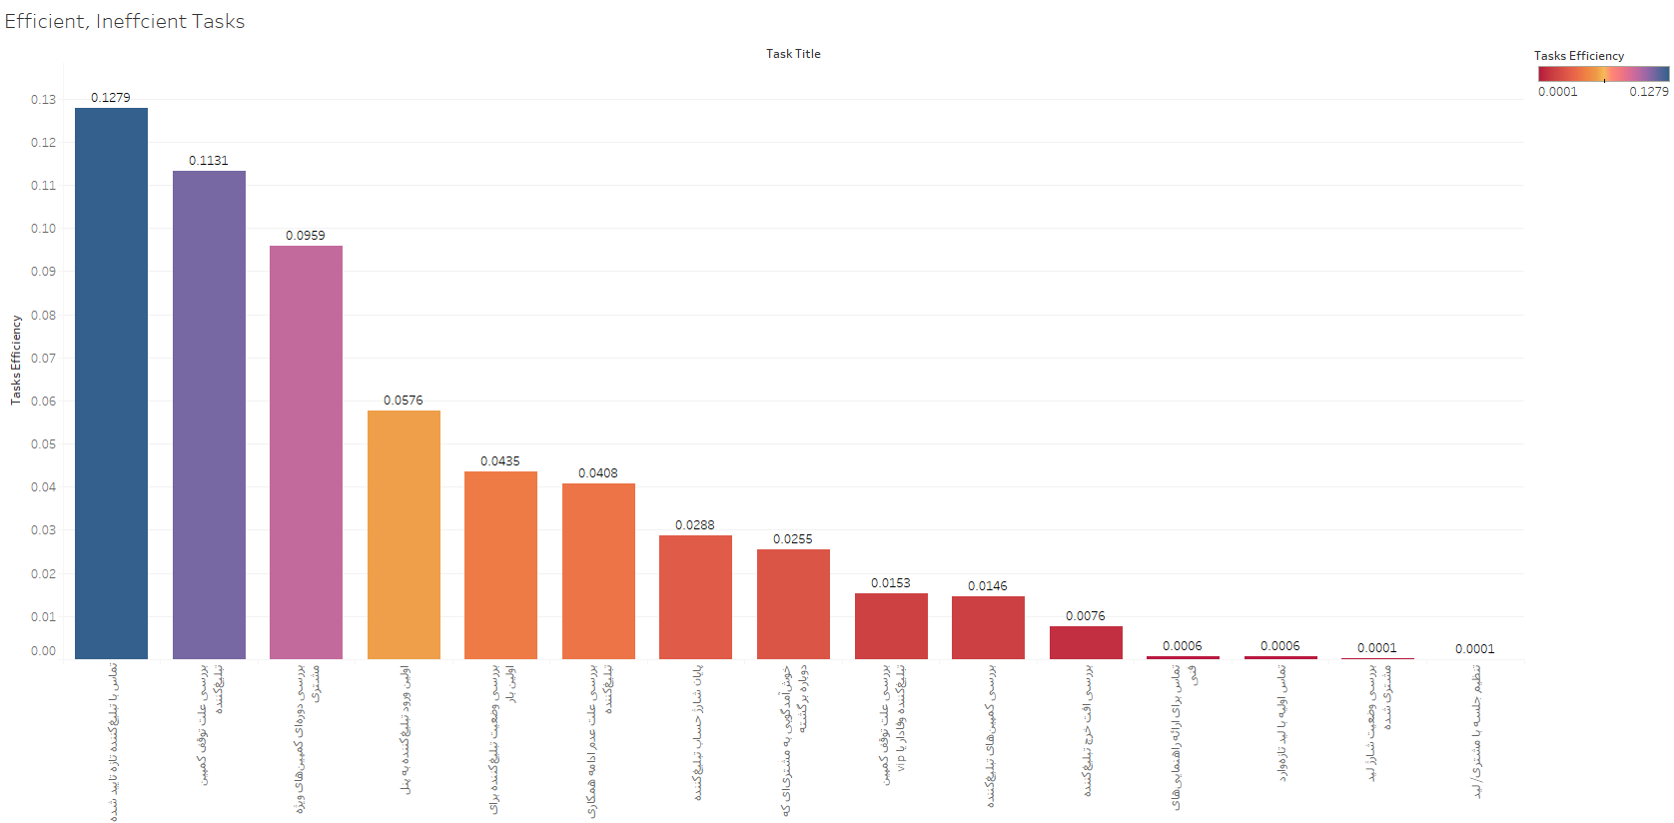

Efficiency is calculated by the derivation below:

Percentage of Total Tasks / AVG([Completion Time])

It is worth mentioning that data about transactions of customers appearing in the Task dataset was not complete so the efficiency in terms of financial aspects couldn’t be modeled.

## Part 5

Efficient, Inefficient Tickets

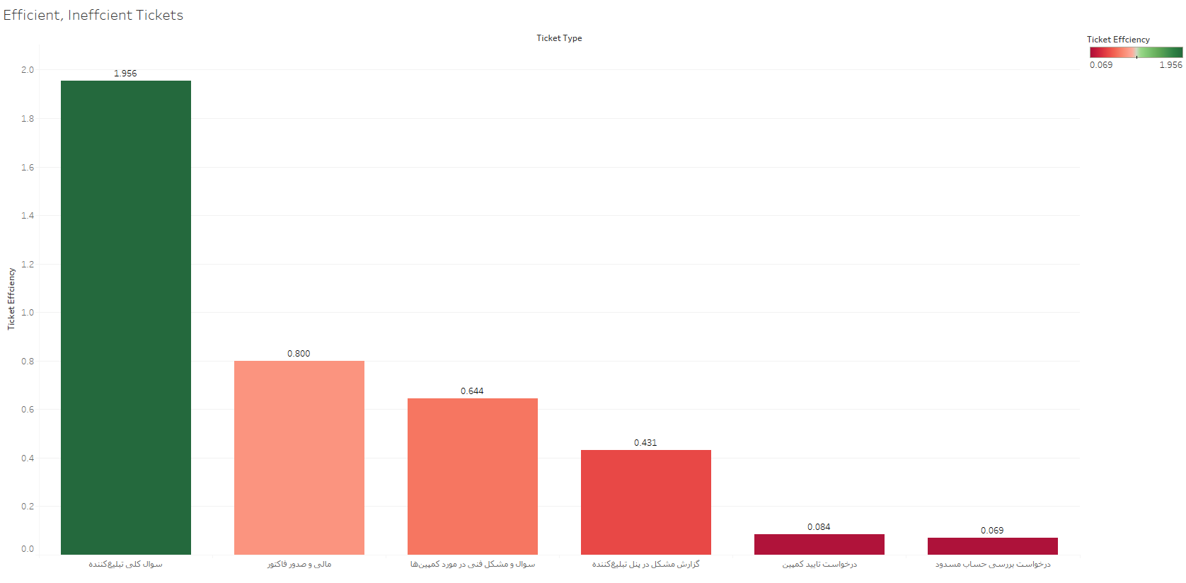

Efficiency is calculated by the derivation below:

Percentage of Total Tickets / AVG([Resolve Time])

## Part 6

Targeting:

I think customers with the highest amount of transaction made or the most frequent ones are the best choice for targeting to improve transaction because they are probably more familiar with the nuts and bolts of the platform and we expect they will deposit more chunks of money than customers with low transaction amounts( Almost 85 percent of customers have deposited less than 50000 cumulatively).

They can particularly be targeted with discounts and loyalty programs offering.

## Part 7

There was a lot of duplicate in the Account and Status dataset I should just pick the most recent status od the customers which lowered the observation number from 8293 to 5609.

In terms of transaction data, there was only the information of 2684 customers so I had to cut them down to merge the two mentioned datasets.

Account Manager 11 only had 2 instances in the dataset which was excluded where necessary.

# Task #3

## Part 1

Evaluating the Current Situation

As Digikala’s main objective lies in increasing sales and marginal profit gained by categories vary greatly, The current status assessment needs two key factors to be evaluated. These factors are:

1. Efficiency

The ratio of adding a product to the online purchase basket in proportion to its views called efficiency and we can understand how much an input traffic source can impact our overall views of a category of products or the way customers were introduced to the products.

In terms of traffic sources, Google organic and direct ads related products respectively have been added to the basket around 0.19 and 0.26 percent of the times while Ad Networks perform poorly considering the massive amount of views they have had. They cumulatively consist of 37 percent of the views.

|  |  |  |  |  |  |  |  |  |
| --- | --- | --- | --- | --- | --- | --- | --- | --- |
| **Traffic Source** | **Viewed** | **Selected** | **Purchased** | **Efficiency** | **Effectivity** | **Purchase Rate** | **Share of Sale** | **Share of View** |
| **Direct** | 1898581 | 3514 | 2085 | 0.185086 | 0.109819 | 59.334092 | 63.067151 | 36.136397 |
| **Google Organic** | 1431849 | 3752 | 954 | 0.262039 | 0.066627 | 25.426439 | 28.856624 | 27.252914 |
| **Ad Network 2** | 1026256 | 483 | 168 | 0.047064 | 0.016370 | 34.782609 | 5.081670 | 19.533111 |
| **Ad Network 1** | 897244 | 390 | 99 | 0.043466 | 0.011034 | 25.384615 | 2.994555 | 17.077578 |
| **Category** | ***Viewed*** | ***Selected*** | ***Purchased*** | ***Efficiency*** | ***Effectivity*** | ***Purchase Rate*** | ***Share of Sale*** | ***Share of View*** |
| **Cosmetics** | 99828 | 5560 | 2125 | 2.128661 | 38.219424 | 38.219424 | 64.277072 | 1.900063 |
| **Fashion** | 287531 | 1324 | 693 | 0.241017 | 52.341390 | 52.341390 | 20.961887 | 5.472684 |
| **Electronics** | 3048472 | 868 | 406 | 0.013318 | 46.774194 | 46.774194 | 12.280702 | 58.022699 |
| **Tools $ Office** | 66180 | 90 | 42 | 0.063463 | 46.666667 | 46.666667 | 1.270417 | 1.259629 |
| **Home Appliances** | 112405 | 31 | 25 | 0.022241 | 80.645161 | 80.645161 | 0.756201 | 2.139446 |
| **Food** | 1639514 | 266 | 15 | 0.000915 | 5.639098 | 5.639098 | 0.453721 | 31.205479 |

From the product category perspective, the most efficient categories are cosmetics and fashion products with 2.13 and 0.24 percent efficiency. The worst efficiency level belongs to the food section with almost zero efficiencies which by the way is completely plausible as this section has been introduced to customers recently and no trust and familiarity have been established yet.

1. Effectivity

Effectivity defines as the number of products being sold divided by the number of views within a specific category or traffic source.

The most effective channel is Direct traffic as expected and it greatly devotes 63 percent of the sales because customers who directly approach a brand’s website are more eager and determined to buy the desired product and also are less likely to show disloyalty. The second most effective one is Google organic as people tend to use search engines to find information about a specific category or product and if they are directed to the website using SEO techniques, they probably can contribute to more sales.

|  |  |  |  |
| --- | --- | --- | --- |
| Traffic Source | Average View | Average Selection | Average Purchase |
| Ad Network 1 | 149540.666667 | 65.000000 | 16.5 |
| Ad Network 2 | 171042.666667 | 80.500000 | 28.0 |
| Direct | 316430.166667 | 585.666667 | 347.5 |
| Google Organic | 238641.500000 | 625.333333 | 159.0 |

|  |  |  |  |
| --- | --- | --- | --- |
| Category | Average View | Average Selection | Average Purchase |
| Cosmetics | 24957.00 | 1390.00 | 531.25 |
| Electronics | 762118.00 | 217.00 | 101.50 |
| Fashion | 71882.75 | 331.00 | 173.25 |
| Food | 409878.50 | 66.50 | 3.75 |
| Home Appliances | 28101.25 | 7.75 | 6.25 |
| Tools $ Office | 16545.00 | 22.50 | 10.50 |

## Part 2

Strategies to Improve Conversion Rate

Strategy 1:

Because cosmetics and fashion products cumulatively consist of around 85 percent of Digikala’s sales, promoting and diversifying them as well as introducing new products in these categories should be the priority of the company in this strategy.

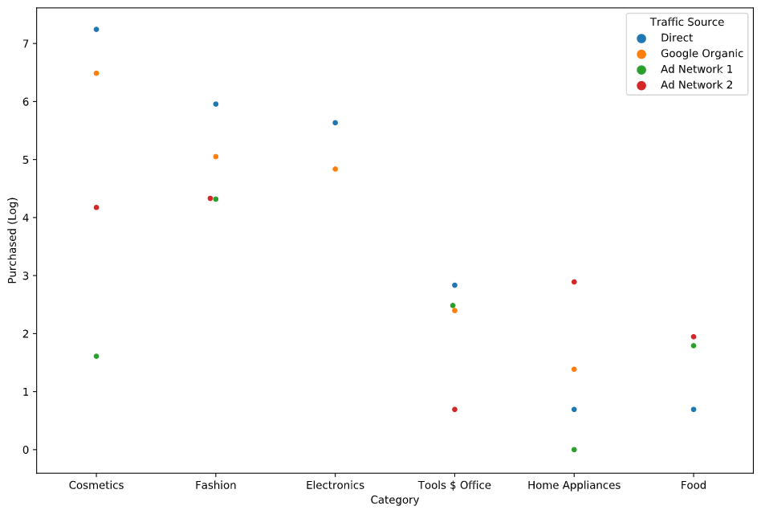

Advantage:

They can easily and freely be promoted on the website and as the figure above suggests the most productive way to promote them is using the direct approach.

Disadvantage:

In this strategy, we lose the opportunity to advertise products like the electronic devices category directly which has zero effectivity and efficiency on other platforms.

Strategy 2

Digikala can choose products with the most purchase rate like home appliances and fashion products to be advertised on platforms with the most share of views like the website and Google organic.

Advantage:

This approach yields us the highest probability of a product being purchased.

Disadvantage:

We completely ignore cosmetics as the most valuable category of products in terms of sales.

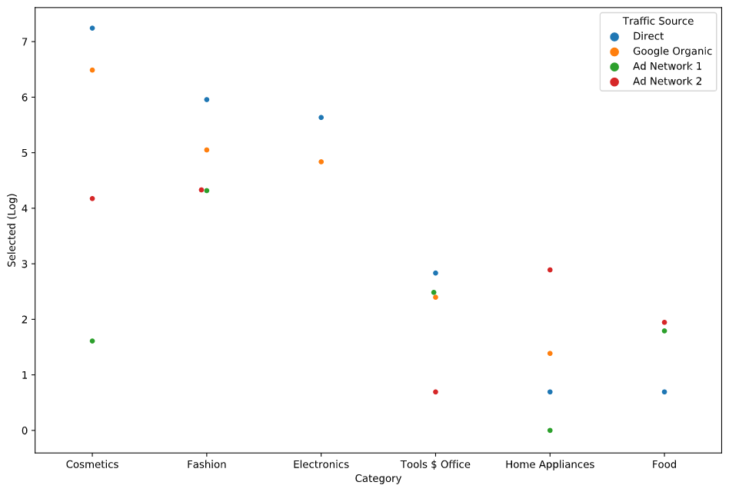

## Part 3

Cooperation Model Building

1. Ad Networks:

In terms of Purchase Rate, Share of Sale, and Share of view, Ad Network 2 outperforms Ad Network 1 by a slight edge. It is highly recommended to keep the connection with both of them as the potentials are high.

Ad Network 2 outperforms all other traffic sources in the Home Appliances category and on the other hand, Both of them show relatively better performance in the food section than the other two.

1. Improving SEO:

Google Organic is the second most profitable traffic source and because of its relatively massive views should be maintained and improved with a high priority.

1. Marketing Strategy of Each Category:

Sources to focus on integrating marketing plans are as follow:

* Cosmetics: Direct, Google Organic
* Electronics: Direct, Google Organic
* Fashion: Direct, Google Organic
* Food: Ad Network 2, Ad Network 1
* Home Appliances: Ad Network 2, Google Organic
* Tools $ Office: Direct, Ad Network 1

Now that it is planned which category is better to be advertised where one prominent way to attract new customers and to make existing customers buy more products is campaigns.

These campaigns should be well developed in terms of improving purchase rates from every specific category. Some products with the highest profit margins should be put on sale to promote other similar products and attract the attention of new customers to make a purchase.

1. Final Decision on Ways to Improve Conversion Rate:

* Diversifying and increasing number of products in each category
* Use the most suitable traffic channel for the marketing of each category
* Focusing on promoting the products with the highest profit margin to the most loyal customers as they are more likely to buy from Digikala
* Use loyalty programs and seasonal discounts to attract or maintain newcomers

1. Final Decision on Improving Digikala’s Sale:

Advertise the most profitable categories on the website and Google Organic and leave other categories to Ad Networks